Ivy Tech PLC Trainers Design Report

Prepared by:
Charity Fischer

Prepared for:
Caitlin M. Cramer

Project Dates:
10 September to 18 October 2019

Date Submitted:
27 September 2019
1 Project Criteria and Requirements
Ivy Tech Community College Fort Wayne has seen the need for developing and using specialized and specific PLC trainers for the purpose of teaching PLC programming. These 3 trainers each require 4 normally closed pushbuttons, 4 normally open pushbuttons, 4 toggle switches, 1 emergency stop button, 12 lights, and have the ability to connect external outputs. The design presented in this report has been through 2 revisions with troubleshooting expected during assembly. However, it meets all requirements and grants greater number of possible outputs than could have been granted.
2 PLC trainer design
The PLC trainers will be comprised of one board on which all the parts will be attached to. This board will be approximately 195mm wide and 450mm tall. Surrounding the board will be a frame that is approximately 246mm wide and 500mm tall. This board can be divided into 3 sections; the top, the middle, and the bottom. The top section will have 3 rows of lights. The first row will have 4 red lights, the second row will have 4 orange lights, and the third row will have 4 green lights. This many lights with a variety of colors will allow for 4096 possible outputs. On the bottom section will be 3 rows of pushbuttons and switches. The first row will have 4 black normally closed pushbuttons, the second row will have 4 red normally open pushbuttons, and the third row will have 4 toggle switches. All pushbuttons, toggle switches, and lights will be 30mm in diameter. The PLC unit will be attached to the middle section of the trainer.
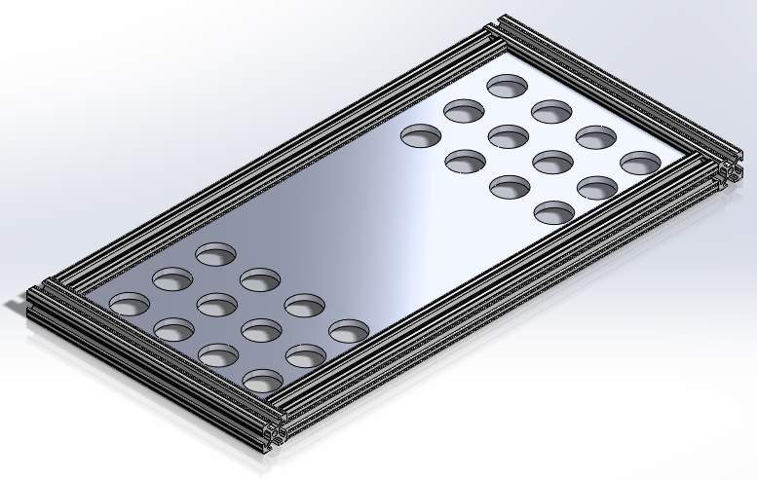

Each light, pushbutton, and toggle switch will be connected directly to the PLC unit.
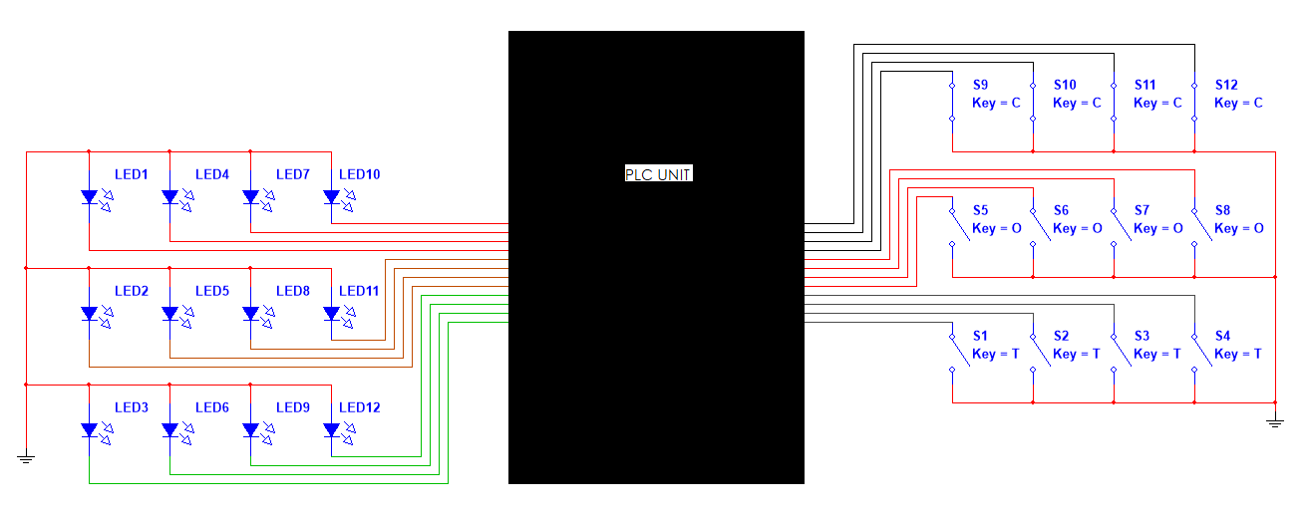
3 Benefits of current design
Having the buttons on the bottom third of the PLC trainer avoids the possibilities of the users hands obstructing view from the PLC unit and the light outputs. A previous design had the pushbuttons and switches on the top third and the lights on the bottom. Having the PLC unit in the center of the PLC trainer allows for all wires connected to it to be clearer as input and outputs are on opposite side of the PLC unit.

